**[Skin Cancer Detection]**

**Team ID: B21-CAP0005**

**Selected theme: Healthcare  
Mentor: Yoyok Gamaliel** (mentoring done on 12, 19, 26 of May 2021 and 2 of June 2021)

**Member : 1. A0030158 - Katherine Rayani Pratama**

**2. A0030161 - Alexander Tri Handoyo Wangsaputra**

**3. M1121438 - Sipky Jaya Putra**

**4. M0030159 - Sherina Melinda**

**5. C0030156 - Cynthia Caroline**

**6. C0030157 - Andreas Aditya Sumasta**

#### **Backgrounder:** Executive Summary:

Based on some articles, skin cancers are one of the most common types of cancers that may affect everyone. Skin cancer is the abnormal growth of skin cells, it usually develops on the skin that are exposed to the sun or radiation. Since many Indonesian still need to work in the open space, they have a high risk of suffering from this disease. We would like to create an application to detect those skin cancers.

Planned Execution:

* Machine Learning: build a model with TensorFlow with a transfer learning method. Using Inception V3 Model to detect the possibilities of skin cancer.
* Android: Create an application that serves as an interface to access the API. Enables users to use the deployed model easily in real time.
* Cloud: Create a REST API Backend Application with Flask framework and deploy that connects to a MySQL instance and deploy it into a Compute Engine Instance and Cloud SQL Instance

Results:

* The current model is not good enough because the images are too big and the model is not big enough. From an application perspective, the dataset needs to include Indonesian skin and obtained by smartphone camera.
* The android application and cloud deployment have no serious problems. With cloud the biggest problem is billing and the biggest problem from android application is API connection.

#### **Screenshots**

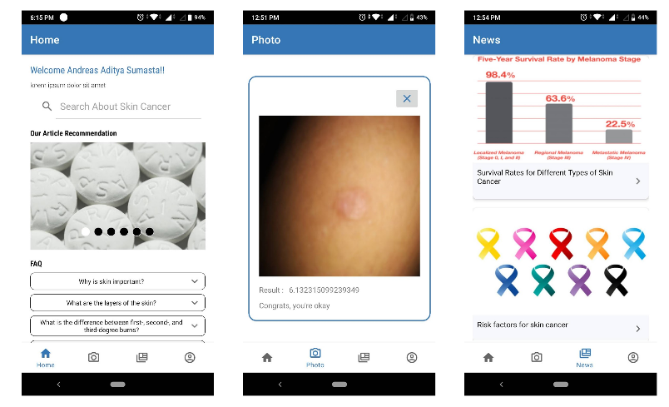

#### **Dataset Link**:

<https://www.kaggle.com/drscarlat/melanoma>

#### **Deployed Link:**

Notebook : <https://colab.research.google.com/drive/1Z0brC7hIEjyd4an2dgj0aStmhYiHxByB?authuser=2#scrollTo=NEn_YPJKyXjn>

APK :

<https://drive.google.com/file/d/14Clryp7wbVyXMdGsGlDC33ifqMVRGyIY/view?usp=sharing>

Go to Market Proposal : <https://docs.google.com/presentation/d/19cnYjMnrekv_lPGb-Hj4xMXPSqMbG-gSXqvUd5-HtEY/edit#slide=id.gdf2064109b_12_3980>

#### **Github Repo Link:**

<https://github.com/Blue-Birman/Bangkit-Capstone-Project-B21-CAP0005>

#### **Academic Paper Link:**

[1] <https://arxiv.org/pdf/1512.00567.pdf> (Inception V3)

[2] <https://eprints.kku.edu.sa/437/1/M-doctor.pdf>

[3] <https://www.irjet.net/archives/V4/i4/IRJET-V4I4702.pdf>

#### **10-Min Video Presentation Link:**

<https://www.youtube.com/watch?v=MbTmtQEcn58>

#### **Slide Presentation Link:**

<https://docs.google.com/presentation/d/1LT7BYbmM75REMKYdQd9QJVA6knP1RurA8aZMpmE33Ks/edit#slide=id.g6ad7e23cbf_0_141>